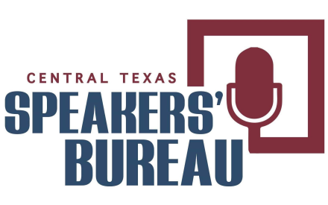

Audience Evaluation

Ask the audience to complete this form and to return it back to the speaker or evaluator.
This form will provide audience feedback to and acknowledge the things that are done well.
This should help the speaker to improve future presentations and pinpoint future topics.
What did you learn from the speaker?

What would you have liked to have heard more information about?

How effective was the presentation?

Was the presentation well organized?

Was the length of the presentation adequate?

Was an adequate amount of time left for questions-and-answers?

Additional comments:_______________________________________________
______________________________________________________________________________

______________________________________________________________________________

______________________________________________________________________________

