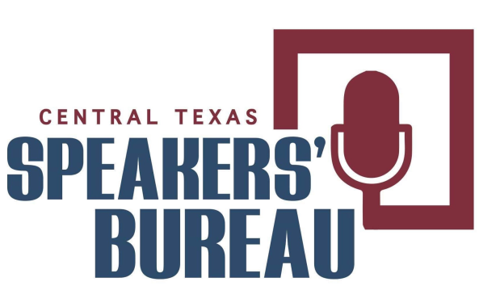
Event Chair Survey

TO BE COMPLETED BY EVENT CHAIRMAN REQUESTING SPEAKER.

AFTER EVENT EMAIL TO SPEAKER AT ____________________________________________

Requesting Organization:________________________ Event Chair Name:_______________________
Event Date:________________________________ Name of Speaker_________________________________
Was the speaker’s message delivered within the time parameters as discussed? Yes or No please circle
Was the message relevant or serve the purpose to the organization or your event? Yes or No
Did the speaker thank the organization, event chairman, and audience? Yes or No
Did the audience seem receptive to the speaker’s message? Yes or No
Was the content of the speech useful? Yes or No
Did the speaker provide an introduction? Yes or No
Was the speaker adequately prepared? Yes or No
Do we have permission to publish the feedback provided as a testimonial? Yes or No
Comments & suggestions for improvement _________________________________________________
______________________________________________________________________________________
______________________________________________________________________________________
______________________________________________________________________________________

